The Deeds look great, thank you the only tweak I would like on them is in the file name, it should read like this: N-10-1-518 - Deed - D_(deed book number) - P_(page number) - Date.pdf The resolution for the deeds isn't that important, as long as they can be read clearly when they are downloaded. So far all of the downloaded deeds have been clear.

It looks like the links expired since you send them over. Its just the maps I want the option to export the URL's into separate text files as they are scraped so that if something is not working correctly I can script it to tweak the url and re-download them before the links expire. the only thing in each file should be the file name its supposed to to be saved as a comma and the url

don't put the brackets in the deed name

also if we put the deed book and page in the file name there will be no duplicates

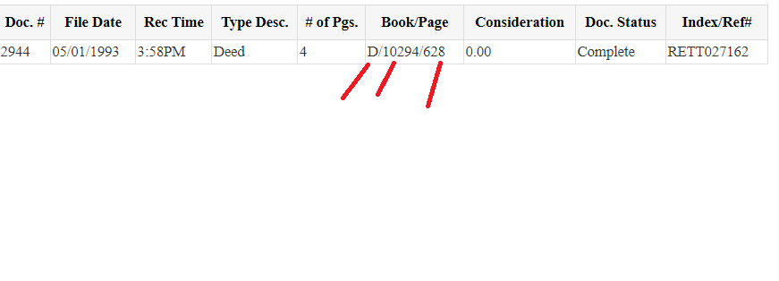

PDF file name format: **N-{Section searched}-{Book searched}-{lot searched} - Deed - D_{deed book number scraped} - P_{page number} - {Date}.pdf**

Maps Filename format: **NM-{map number} - {Map Title} - {File Date}**

For the deeds we need all pages of images

maps typically have 1 page, however in rare cases there are multiple pages. if there are, pull them all

the deeds don't really need separate csv files but if its already doing it then just keep it. all the info for deeds can go into a single csv for whatever it pulls. it will be a nice summary of what it was able to pull